WHALLEY, WISWELL & BARROW JOINT BURIAL GROUND

A secluded burial ground hidden away on Clitheroe Road between the villages of Whalley and Barrow, providing a peaceful setting for traditional burials, woodland burial of ashes and the scattering of cremated remains.

The Cemetery is owned jointly by Whalley, Wiswell and Barrow Parish Councils and managed by Whalley, Wiswell and Barrow Joint Burial Committee.

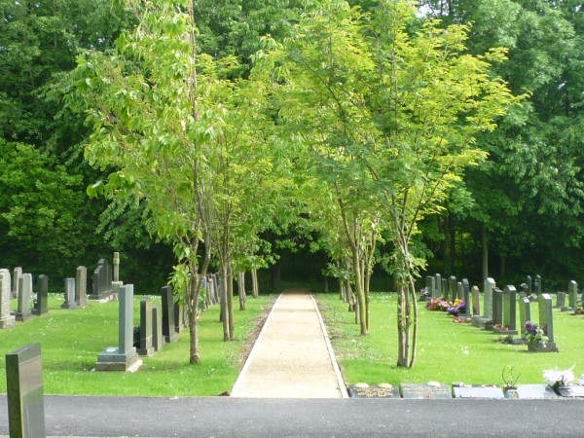

LAWN CEMETERY AND PATH SIDE PLOTS
The main area of the burial ground is lawn and given to grave plots. There are two distinct separate areas. One side is for the Roman Catholic faith, the other for Church of England and other faiths. Path side plots edging the lawn section on the Church of England side are for the interment of ashes as are those under the hedgerow at the Roman Catholic side. The lawned area is cared for by our Groundsman who attends on a fortnightly basis during the summer months and once per month in winter.

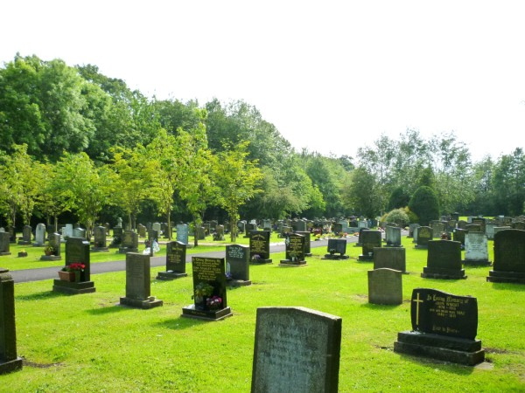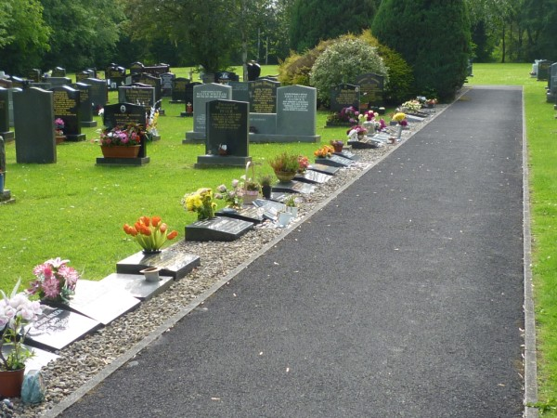

WOODLAND AREA
A beautiful woodland area, exclusively for the interment of ashes, which offers a truly beautiful alternative to a traditional burial ground setting. Bounded by a stream, plots are set amongst trees, providing the perfect setting in which to remember your loved ones. Paths have been laid so that it can be navigated and there are benches to just sit and contemplate. This area is left mostly wild, with only minimal interference, to encourage the natural habitat.

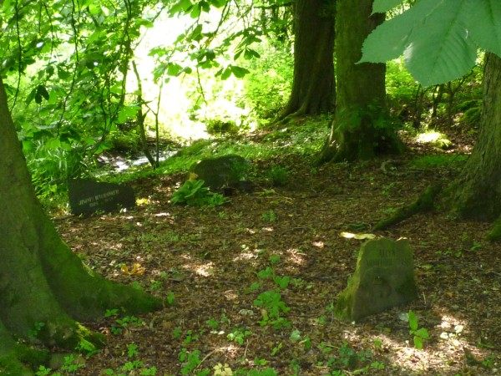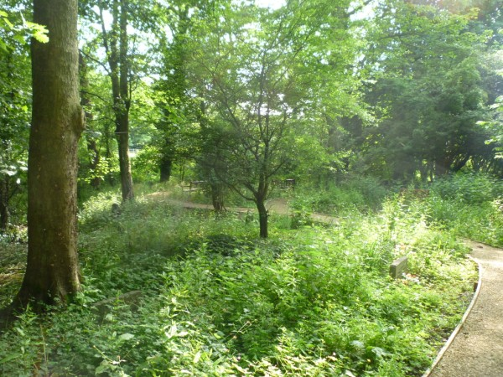

FUNERAL ARRANGEMENTS
The funeral director of your choice will make all arrangements with the Registrar for the funeral. The Registrar deals with all the paperwork and organises the interment.

VISITING THE BURIAL GROUND
The Cemetery is open between 7.30 am to sunset. All we ask is that children are accompanied, and dogs kept on a lead and cleared up after where necessary.
There is no car park but there is a turning circle and entrance area, although these may have to be kept clear if there is a burial in progress. There is also unrestricted parking on the main road.

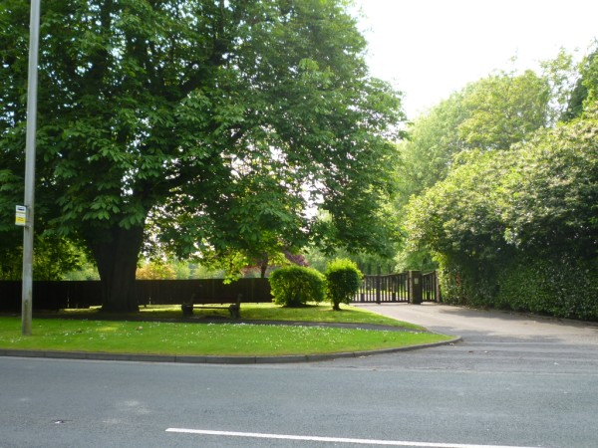

CONTACT
For further details contact the Registrar
Tel: 01254 722811 Email: registrar@wwbjbc.org.uk

